Report

Bioreactor control and monitoring system

1)Introduction

Member list:

* Nimit bakrania
* Felipe
* Jamil mohammed
* Konrad chan
* Wei DAI
* Xincheng cai
* JACK
* JOEY SUN
* DYLAN
* Alex burner

2) Subsystem descriptions

2.1 PH= Subsystem B + Subsystem C 2

2.1.1 PH Probing 2

2.1.2 PH Pumping 3

2.1.3 PH Results/Validation

2.2 Stirring 3

2.3 Hea7ting

3) User Interface

4) Overall System Integration and Summary

Introduction

Author: Nimit Bakrania

The ENGF0001 Challenge 2 is a inter-disciplinary project based on global health that entails designing and developing a bioreactor control and monitoring system that: monitors system parameters, provides the user with real time system information, allows for user adjustment of the syste parameters and logs the system parameters for process quality control.

The purpose of the bioreactors are that they are designed to maximise cell growth, yet they are expensive. Our project is geared to create small scale models that will be indicative of the behaviour of the larger scale versions.

Our role in this was the building of a functioning prototype bioreactor for the production of this vaccine.

This includes the positioning of the system geographically, the managing of the energy usage, cost (CEGE-ME specialist project), the developing and adjustment of the chemicals to be used (BE-CE-BME specialist group) and the physical control system (including both the electronics and user interface) (Cs-EEE specialist group).

The bioreactor had certain requirements it must meet and mutiple parts to it. The hardware of the bioreactor consists of mutiple subsystems that are combined (some used independently) to create a complete bioreactor. Here are the subsystems used and a few aspects of each:

Power supply:

* A 12V, 7AH Rechargable lead acid battery with a 12 V and 6 V output.

Microcontroller:

* MSP432-P401R Launchpad.

Heating:

* A 3Ω, 30W heater element, that can be immersed.
* 10kΩ NTC Termistor (ND06P00103K).
* This subsystem involved

Stirring:

The output from the stirring subsystem needs to be read by the microcontroller.

* 3V DC motor (Maximum current 1A).
* CP2S700HCP Photo-interrupter device attached to the top of the motor.
* This subsystem involved

pH:

A pH electrode measures hydrogen ion (H+) activity and produces an electrical potential or voltage. The pH subsystem for the bioreactor consists of:

* pH probe (PH-100ATC Probe).
* Two 6V, 1A peristaltic pumps
* This subsystem involved

User-interface

Our user interface allows for two-way communication between the user and the bioreactor, allowing such user to see displayed data, alerts/messages and allows input from the user.

I.E Meetings- “Aside from technical considerations what else will you have to take into account if you were planning this project for real?”

To answer this, we have to consider the focus of our project to begin with- the people of Uganda. Our aim is to make the vaccinations for Tuberculosis be as accessable to as many people as possible, even if they live in a desolate location. So to achieve this, there are a few problems that we are to solve. To start with, we can assess the issue of how many people can be vaccinated to begin with and how the vaccine can be distributed due to lack of access. The main concern of vaccination is in the young- vaccination is most efficient and helpful when given to children as if they are not given at a certain age, it increases the likelihood of getting tuberculosis. The solution to issue of the lack of general access is to contact external doctors and have them spread throughout Uganda. This is because there is a minimal amount of public hospitals.

The next point to take into account would be to find a language on the interface the locals can interact with. Also, find an alternate energy from a factory that is reproducible and more environmentally friendly. After some research, we found that the most popular languages in Uganda are English and Swahili. However, for the parts that have a less well knows language, the solution would be to deploy a translator for that region. Also for the issue with the energy for the factory, a suitable energy source would be a dam. There are about 132 power stations in Uganda and we would only need to use 5 which are dams to solve the energy issue.

The possible instability and corruption of local governments is an extremely troubling factor on which the project relies upon. Bringing a lot of uncertainty to the table as the changing of the ruling power could effectively end it. The lack of a regulated political regime also allows big pharmaceuticals to influence the decision makers putting the project under pressure. As the providing of cheap or even free vaccines by an external organisation is not something desirable to happen for a company which is currently benefiting from the sale of the former.

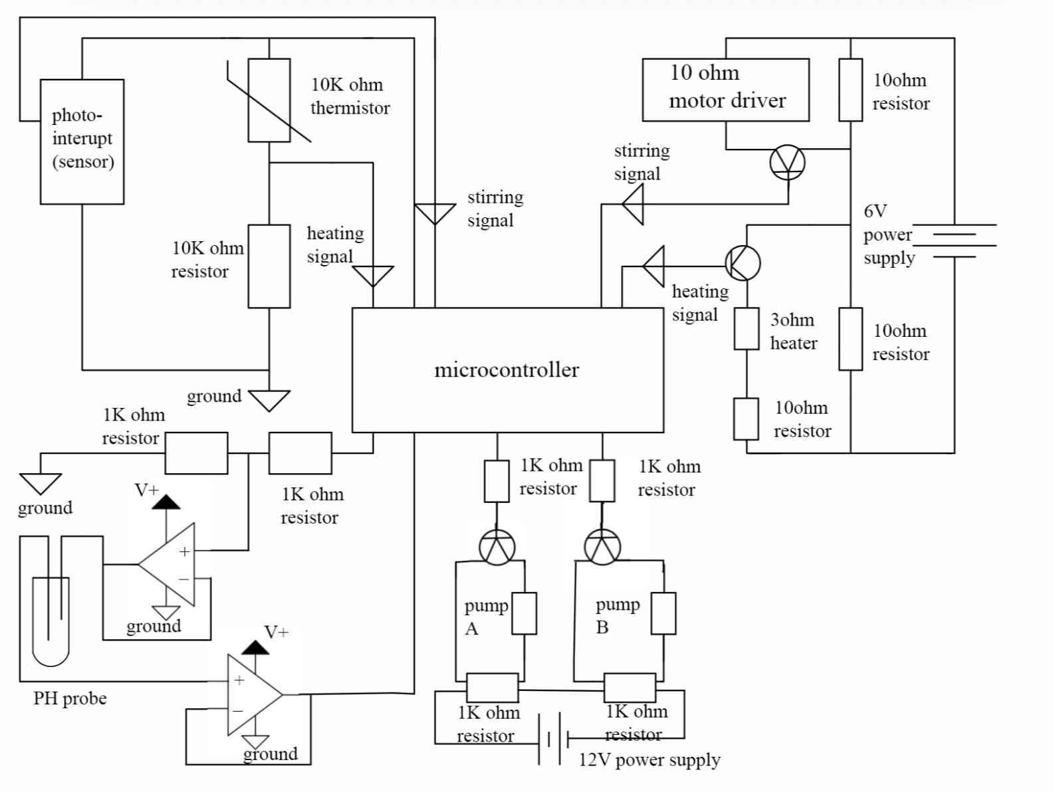Overall Circuit

2.1.1 pH Regulation subsystem

Author: Konrad Chan

Aim of building pH system:

Growth of the yeast in the bioreactor system is highly dependent on the acidity of the environment, as such an acidity regulation system must be built in order to stabilise the pH of the environment within the optimum range for maximum growth (pH 4.5 < pH of the solution < pH 5.5). The pH regulating subsystem can be divided into parts: the probing system and the pumping system. The probing system measures the acidity of the solution using a digital pH probe, and the pump system pumps an acidic or basic solution depending on whether the measured pH above 5.5 or below 4.5 respectively.

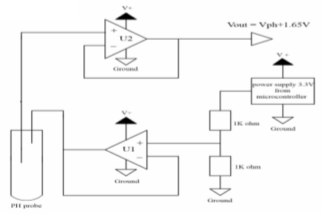**pH probing system:**

This system consists of the following components:

1. Two 1kΩ resistors

2. An MCP6244 op-amp

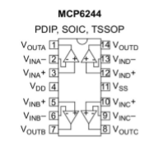

3. pH electrode

4.Microcontroller

The power supply to the system is obtained from the microcontroller’s 3.3V pin. This voltage is then divided to 1.65V by a potential divider built with two 1kΩ resistors before feeding into the first op-amp,U1. It is set up in a unity-gain configuration and connected to the negative pole of the PH probe in order to stabilize its potential. And the positive electrode of the pH probe is connected to the non-inverting input of the second op-amp,U2. Because of large impedance of PH probe, we need an op-amp which is unity-gain configuration to offset it.

The unity-gain configuration of the op-amp gives a voltage offset of 1,65V. As such, the final output voltage at output U2 is the sum of the voltage produced at the pH electrode and 1.65V voltage offset. Output of U2 is then connected to a pin on microcontroller to enable the analogue input on the terminal of our computers.The pH probe outputs a digital signal which is read using the analogread function. This digital signal is then converted to pH using mathematical conversions in the program. The conversion is : pH electrode’s sensitivity= 0.000198T V/pH =R*T*ln(10)/F F is the Faraday constant=9.6485309*10^4 C mol^-1 R is the universal gas constant=8.314510 J K^-1 mol^-1 T is the temperature the read the heating team maximum voltage=1.65+0.000198*7*T minimum voltage =1.65-0.000198*7*T The range of voltage is 0 to 3.3V and the range of analogRead is 0 to 1024 maximum analogRead value =(1024/3.3)* maximum voltage minimum analogRead value=(1024/3.3)* minimum voltage

Then the analogRead value is converted into pH value.

The conversion is: m=(0-14)/(maximum analogRead value - minimum analogRead value)

b=-(1024/3.3)*maximum analogRead value*m

pH value=m*analogRead value+b

**Pump system:**

The pump system regulates the acidity of the solution by pumping an acidic or basic solution depending on the probe measurement. The system is powered using a 12V power supply evenly split between two pumps using a voltage divider system. Each pump is connected to a transistor which is also connected to a different pin in the launchpad. The launchpad outputs a signal depending on the pH probe reading: A signal outputs to the basic pump when pH is less than 4.5; A signal outputs to the acid pump when pH is greater than 5.5; There would be no output when the pH is within the optimum range (4.5 - 5.5). A signal from the launchpad closes the transistor, closing the circuit in the respective pumps, therefore activating them. This allows the pH to be regulated in the yeast solution.

**Design**:

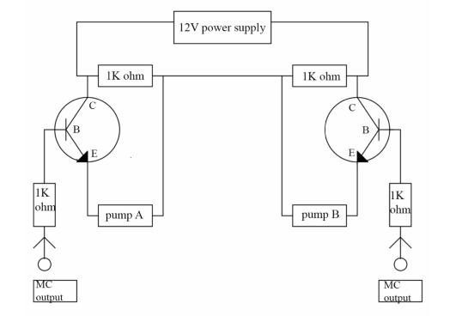

**Components**:

- Two 1kΩ resistors divide voltage evenly to the pumps

- Transistors open and close circuits depending on a signal from the launchpad

- 1kΩ resistors connected to launchpad to control current

### 2.2 Stirring subsystem

Author: Wei Dai

**The aim of stir system:**

The purpose of stirring is to assist with the other two subsystems: heating and PH pump. As the vaccine production needs suitable solution concentration to operate, it is obviously impossible to get a uniform concentration of solution just after heating and PH pump works because the heat energy and vaccine solution is not even distributed at each position of the solution. Stirring is then needed to increase the fluent motion by inputting mechanical energy to reduce the time consuming of obtaining a homogeneous solution. However, it does not mean that high speed motion of motion is always goods because spinning oar may change the structure of protein and splash the solution out of the beaker. That’s why the speed of motor must be controlled within the range from 500 to 1500 rotations per minute.【1】【2】

**How stirring works:**

There are two parts of stirring, sensor part and Motor Drive. As the diagram illustrated below. The left part of the circuit can detect the number of rotations per minute (RPM) of the motor. Microcontroller supplies a 3V to the photo-interrupt which is the sensor, the sensor detects the motion of motor and sends back a square wave formed by zero and one to the Microcontroller. According to the working principle of sensor, two couples of zero and one means one rotation of motor and Code Composter Studio (CCS) can program the microcontroller by using the time taken code “pulseIn” to obtain the period of the motion of motor thus calculate the RPM.

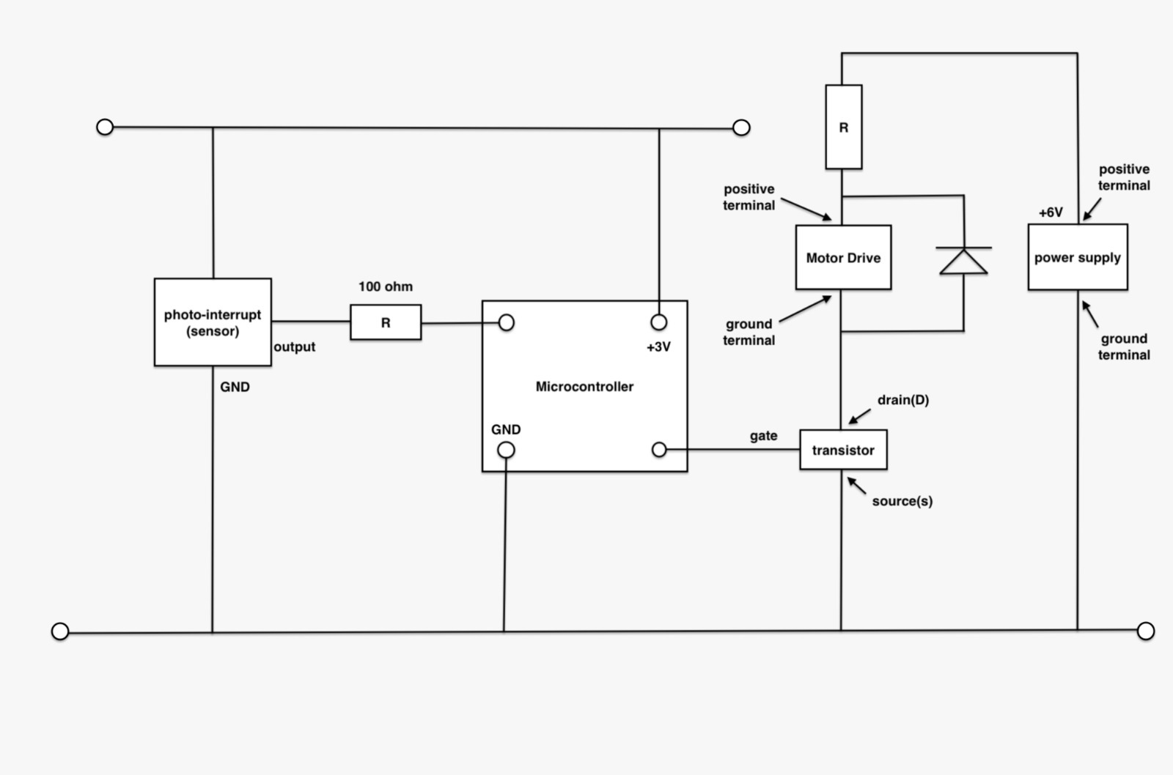On the right part of the circuit diagram is about Motor Drive, the power supply is used to drive the motor and the transistor is considered as a switch in the circuit so speed of motor can be controlled by switching on and off the gate by changing the pin voltage output of the Microcontroller. The Zener diode parallel to the Motor Drive is used to protect the motor from reverse current.

### Heating control subsystem

Author: A. Berner, Jack

Jack Guo

* Description of subsystem C

Purpose of heater/ Why we need it：

This purpose of this subsystem was to monitor and regulate the temperature of the water in which the yeast was to be grown. As the yeast grows, the temperature of the water it is in will change. The subsystem which we designed was able to measure the temperature in the beaker and change it to the temperature requested by the user. The BE-CE-BME group had requested for this subsystem to operate in the temperature range of 30°C-35°C

The circuit for this subsystem had two main parts: temperature measurement and heating.

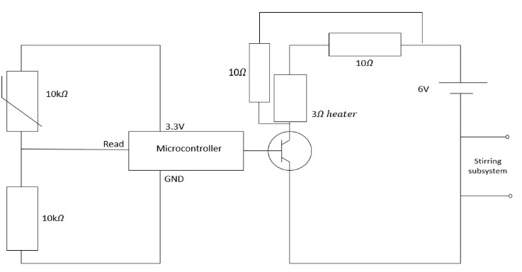

Figure 1: The left half of the circuit was responsible for measuring the temperature. A potential divider circuit consisting of a 10kOhm resistor and a 10kOhm thermistor was used. This was powered by the 3.3V pin on the microcontroller. As the temperature changed, the resistance of the thermistor also changed. The microcontroller would then read a digital value corresponding to the share of voltage going to the resistor. This digital value would have no

Figure1

meaning to the user.

Figure 1: The right side of the circuit was responsible for the heating of the water. A transistor was used as a switch to regulate whether the heater was on or off. The signal for this was sent by the microcontroller and was dependant on the required temperature (set by the user). Upon testing the circuit, the heater would heat up way too quickly (when connected to a 6V supply). We then decided to split the 6V supply between the heating and stirring subsystems. In that case, there is a 10ohm resistor in series with a heater to share 6 V with stirring. In addition, a second 10ohm resistor is supposed to be in parallel with thermistor and resistor, which ensure enough current can flow, hence enough power.

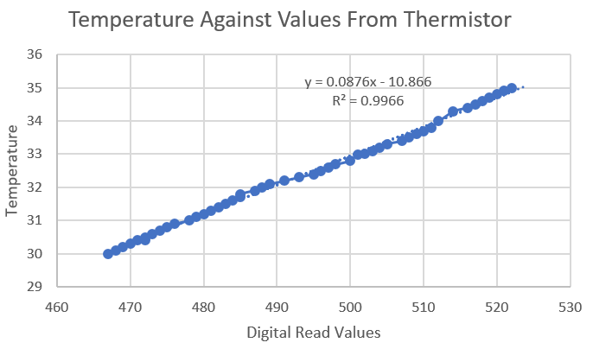

Temperature Against Digital Read Values

Figure 2: We had to test which values of temperature corresponded to the digital readings we received from the potential divider. Once this data was collected, we plotted a graph which could be used to find a relationship between the two variables. An equation of the line we plotted could be used in the code so that the microcontroller would be able to convert the digital read values to temperature

Figure 2

Figure2

### 2.4 User Interface for Bioreactor Control System:

Author: Jamil Mohammed

One of the main aspects of the bioreactor control system that needed to be achieved was to design a functional user interface where the user would be able to interact with the bioreactor. In terms of the UI’s functionality, we decided it should be capable of displaying current and previous data points for the three subsystems as well as allowing the user to change the values for the temperature and stirring speed of the bioreactor. To produce this user interface, we decided to use the ControlP5 library within the Processing software. This library, in addition to basic Java, allowed us to create the basic design of the UI by incorporating buttons, text fields, graphs and labels to help the user in managing the bioreactor efficiently.

For our UI to be able to both monitor the data received from the bioreactor for each of the three subsystems as well as send any inputted data back to the bioreactor, we needed to implement a system that would allow two-way communication between the user interface and the microcontroller containing the sketches for each of the subsystems. An issue we had with this was that all the communication was happening on the same serial port which meant there was no elegant way for the microcontroller to be able to differentiate between whether a line on the serial monitor was an output coming from the bioreactor or an input going to the bioreactor. We had suggested ways that would hypothetically separate these categories (such as prefixing the values with a letter ‘i’ or ‘o’ depending on whether it was an input or output respectively), but unfortunately, we were unable to implement this for our final user interface. As a result, the UI’s main functionality was to receive the correct values for each subsystem and plot the data on its respective graph as well as displaying the value at the top of the window.

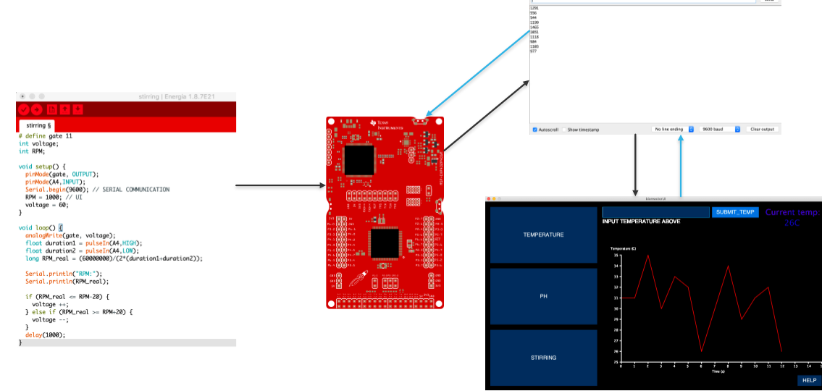In addition to the main functionalities that the UI needed to have, our team decided to integrate various features that would better the quality of life for the user of the UI in Mbarara. The first way we managed to do this was by adding some ‘help’ text which instructed the user on what they would need to do next in order to operate the user interface. This text would be displayed on the screen whenever the UI was first started up or whenever a dedicated ‘help’ button was pressed on the bottom-right corner of the window. We also decided to colour code the label at the top of the screen displaying the values for each subsystem by implementing a switch-case statement that causes the label to become ‘more red’ as the value increases and ‘more blue’ as the value decreases. Another possible feature that we would consider enforcing in the future would be an option to translate the text on the UI to the various languages spoken in Mbarara, including Swahili and Luganda, which would allow us to overcome the language barrier for factory workers at the vaccination facility.

### Overall System Integration and Summary

Author: Nimit Bakrania

**Stirring**:

Can we accurately decrease the speed and increase the speed of the stirring at will?

The stirring system can change the speed within the range as will. The time it takes to reach the speed that user wants is at most 4-5 seconds. The fluctuation Varys from 100 to 500RPM, some times 1000RPM. The reason that it takes a long time and the huge fluctuation is because we directly supply a 6V to the motor at the last demo, which we only needs 2.7 V.

Problems:

The problem during the testing is listed:

1.The photo-interrupt does not show the exact reading on the computer. Reason: The resistance of protection resistor is too huge so the voltage across the sensor is too small that’s why sensor doesn’t work. Solution: replace it with lower resistance

2.The demanded speed doesn’t match the real speed. Reason: the voltage across the motor is very large so the transistor used for controlling actually is useless. Solution: lower the voltage supply.

Hence, the stirring system is now able to work efficiently and effectively as required. There results where quite accurate and there was a very small deviation between the real value and tested ones.

**Heating** - How well does the heating work? - ie last demo heating caused temperature to fluctuate when we tried to increase water when in reality it should’ve increased it constantly it all up

For the demonstration, the value of temperature that displayed on the terminal is fluctuating( almost 1 ℃) while we are running the system. We decide to put an extra 10 ohm resistor in parallel with both stirring and heating part in order to drive more current and hence larger power. (Flucuation may caused by insufficeint power.) In that case, the power should be suitable to heat up and cool down as well.

The heating subsystem works accurately and functions with an LED. However, with more time for testing we could have covered more ground on the effectiveness of the heating unit and if it truly covers all values it needs to.

**pH**:

The pH subsystem reached the goal successfully making a system able to identify the pH of the solution and been able to change it, within an accuracy of 0.5. However the pumps did have a short circuit when all of the 3 systems were integrated together, not making us able to deliver the overall integrated circuit. We managed to solve this issue by correcting our wiring which was at fault, allowing out pH subsystem to be somewhat effecting at carrying out its task. Our result can be seen in Appendix 6.

**UI**:

The User Interface provided the user with easy and convenient access to the control system, without worrying about the complex designs behind the screen. The UI precisely and clearly displayed the current reading with a graph in such a way so that the user could set the desired input value with simple operation, and be told if the values entered where not in the specified range.

Appendix

[1] <https://www.vogel.com.cn/top/2017/cipm/article_view.html?id=439602>

[2] https://link.springer.com/article/10.1051/dst/2009043

[3] Heating :

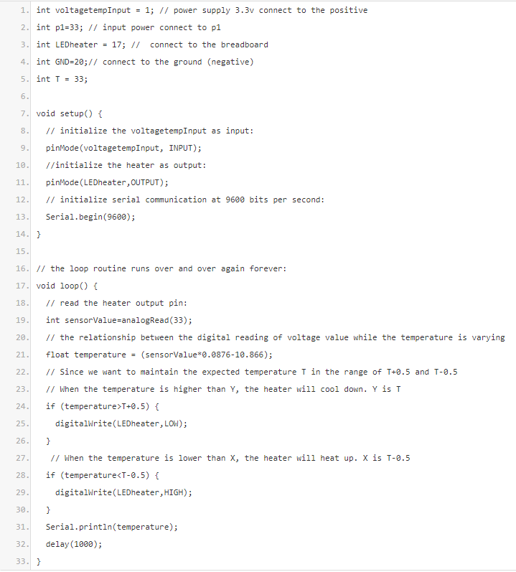

[4] Stirring:

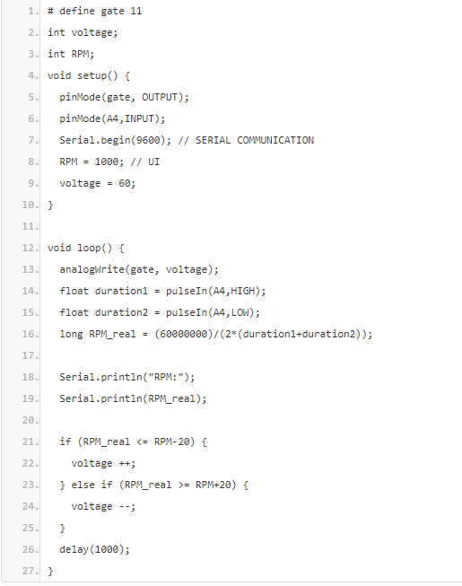

[5] pH:

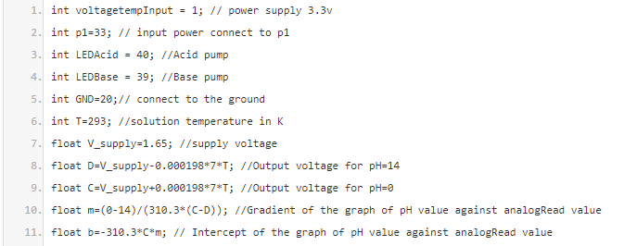

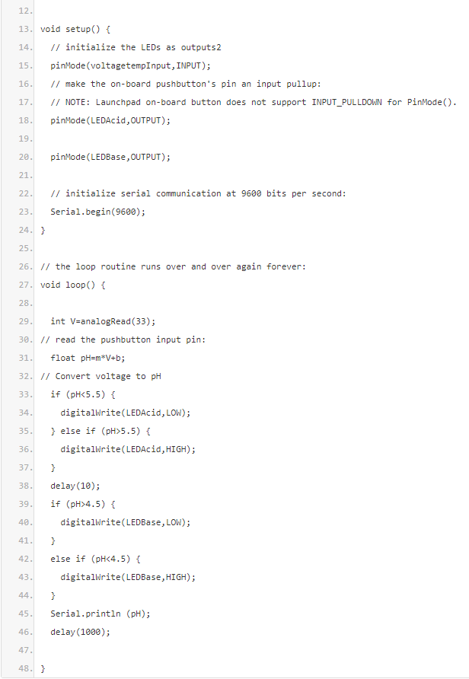

[6] We plot a graph about PH value against output voltage. the blue line represents the theoretical value which is calculated by the formula and we also choose the closest values which are green points shown on the computer in 3 seconds intervals. in addition, we obtain the mean value of our mearsurement in 3 seconds intervals, which are red points. as shown in the graph, although there is a difference between theoretical values and the mean values from measurement, we still obtain decent measurements by our PH probing system.